Software Programming Unit — Project Report
Project: Library Automation System
A Java console application implementing Add / Edit / Search / Delete operations

NVQ LEVEL 5
Farook Musarraf

1. Introduction
This report documents the individual software project completed for the Software Programming unit: a Java REST API backend for the Library Automation System. The backend implements full Create, Read, Update and Delete (CRUD) functionality for library members and books, together with the loan issue/return workflow and automatic overdue-fine calculation, exposed over HTTP as JSON endpoints. This design was chosen deliberately over a console application because the Web Programming unit's site (Unit 11) needs a live backend to call the same Library Service business logic now serves a real browser front-end instead of a text menu. The design follows the relational schema produced for the Database Systems unit, so the class model maps directly onto the Members, Books and Loans tables.

2. Problem Definition and Scope
Manual, paper-based tracking of book lending is slow and error-prone: staff cannot easily tell which copies available, which loans are overdue, or how much a member owes in fines. This project solves that problem for a single library branch with the following scope:
- Add, search, edit and delete member records — over HTTP, as JSON.
- Add, search, edit and delete book records (including copies count) — over HTTP, as JSON.
- Issue a loan against a specific member and book, enforcing business rules (active membership, available copy).
- Return a loan and automatically calculate any overdue fine (Rs. 30/day).
- List all currently overdue loans.
- Serve the Web Programming unit's front-end files directly, so the whole system runs from one process during a demonstration.
Out of scope for this build: a live network database connection (the persistence layer is designed to be swapped for JDBC against the MySQL schema without changing the service or API layers — see Section 3.1) and user authentication (not required for the unit's evidence).

3. System Design

3.1 Layered Architecture
The application is split into four layers so that each class has a single, clear responsibility:
Layer | Package | Responsibility
Model | com.library.model | Plain data classes: Member, Book, Loan and their status enums.
Repository | com.library.repository | CRUD storage behind a common Repository<T,ID> interface. Implemented in-memory here; a JDBC implementation against the MySQL schema could be substituted with no change above this layer.
Service | com.library.service | LibraryService — all business rules (validation, loan eligibility, fine calculation) live here, independent of how data is stored or presented.
API | com.library.api | ApiServer plus MembersHandler / BooksHandler / LoansHandler — a REST layer built on the JDK's own com.sun.net.httpserver.HttpServer that translates HTTP requests into LibraryService calls and JSON responses. Also serves the Web Programming unit's static front-end files.
Because business rules live only in the Service layer, the exact same LibraryService class that was unit-tested for the Software Testing unit is now driven by HTTP requests instead of a console menu — no business logic changed when the presentation layer changed.

3.2 Class Diagram
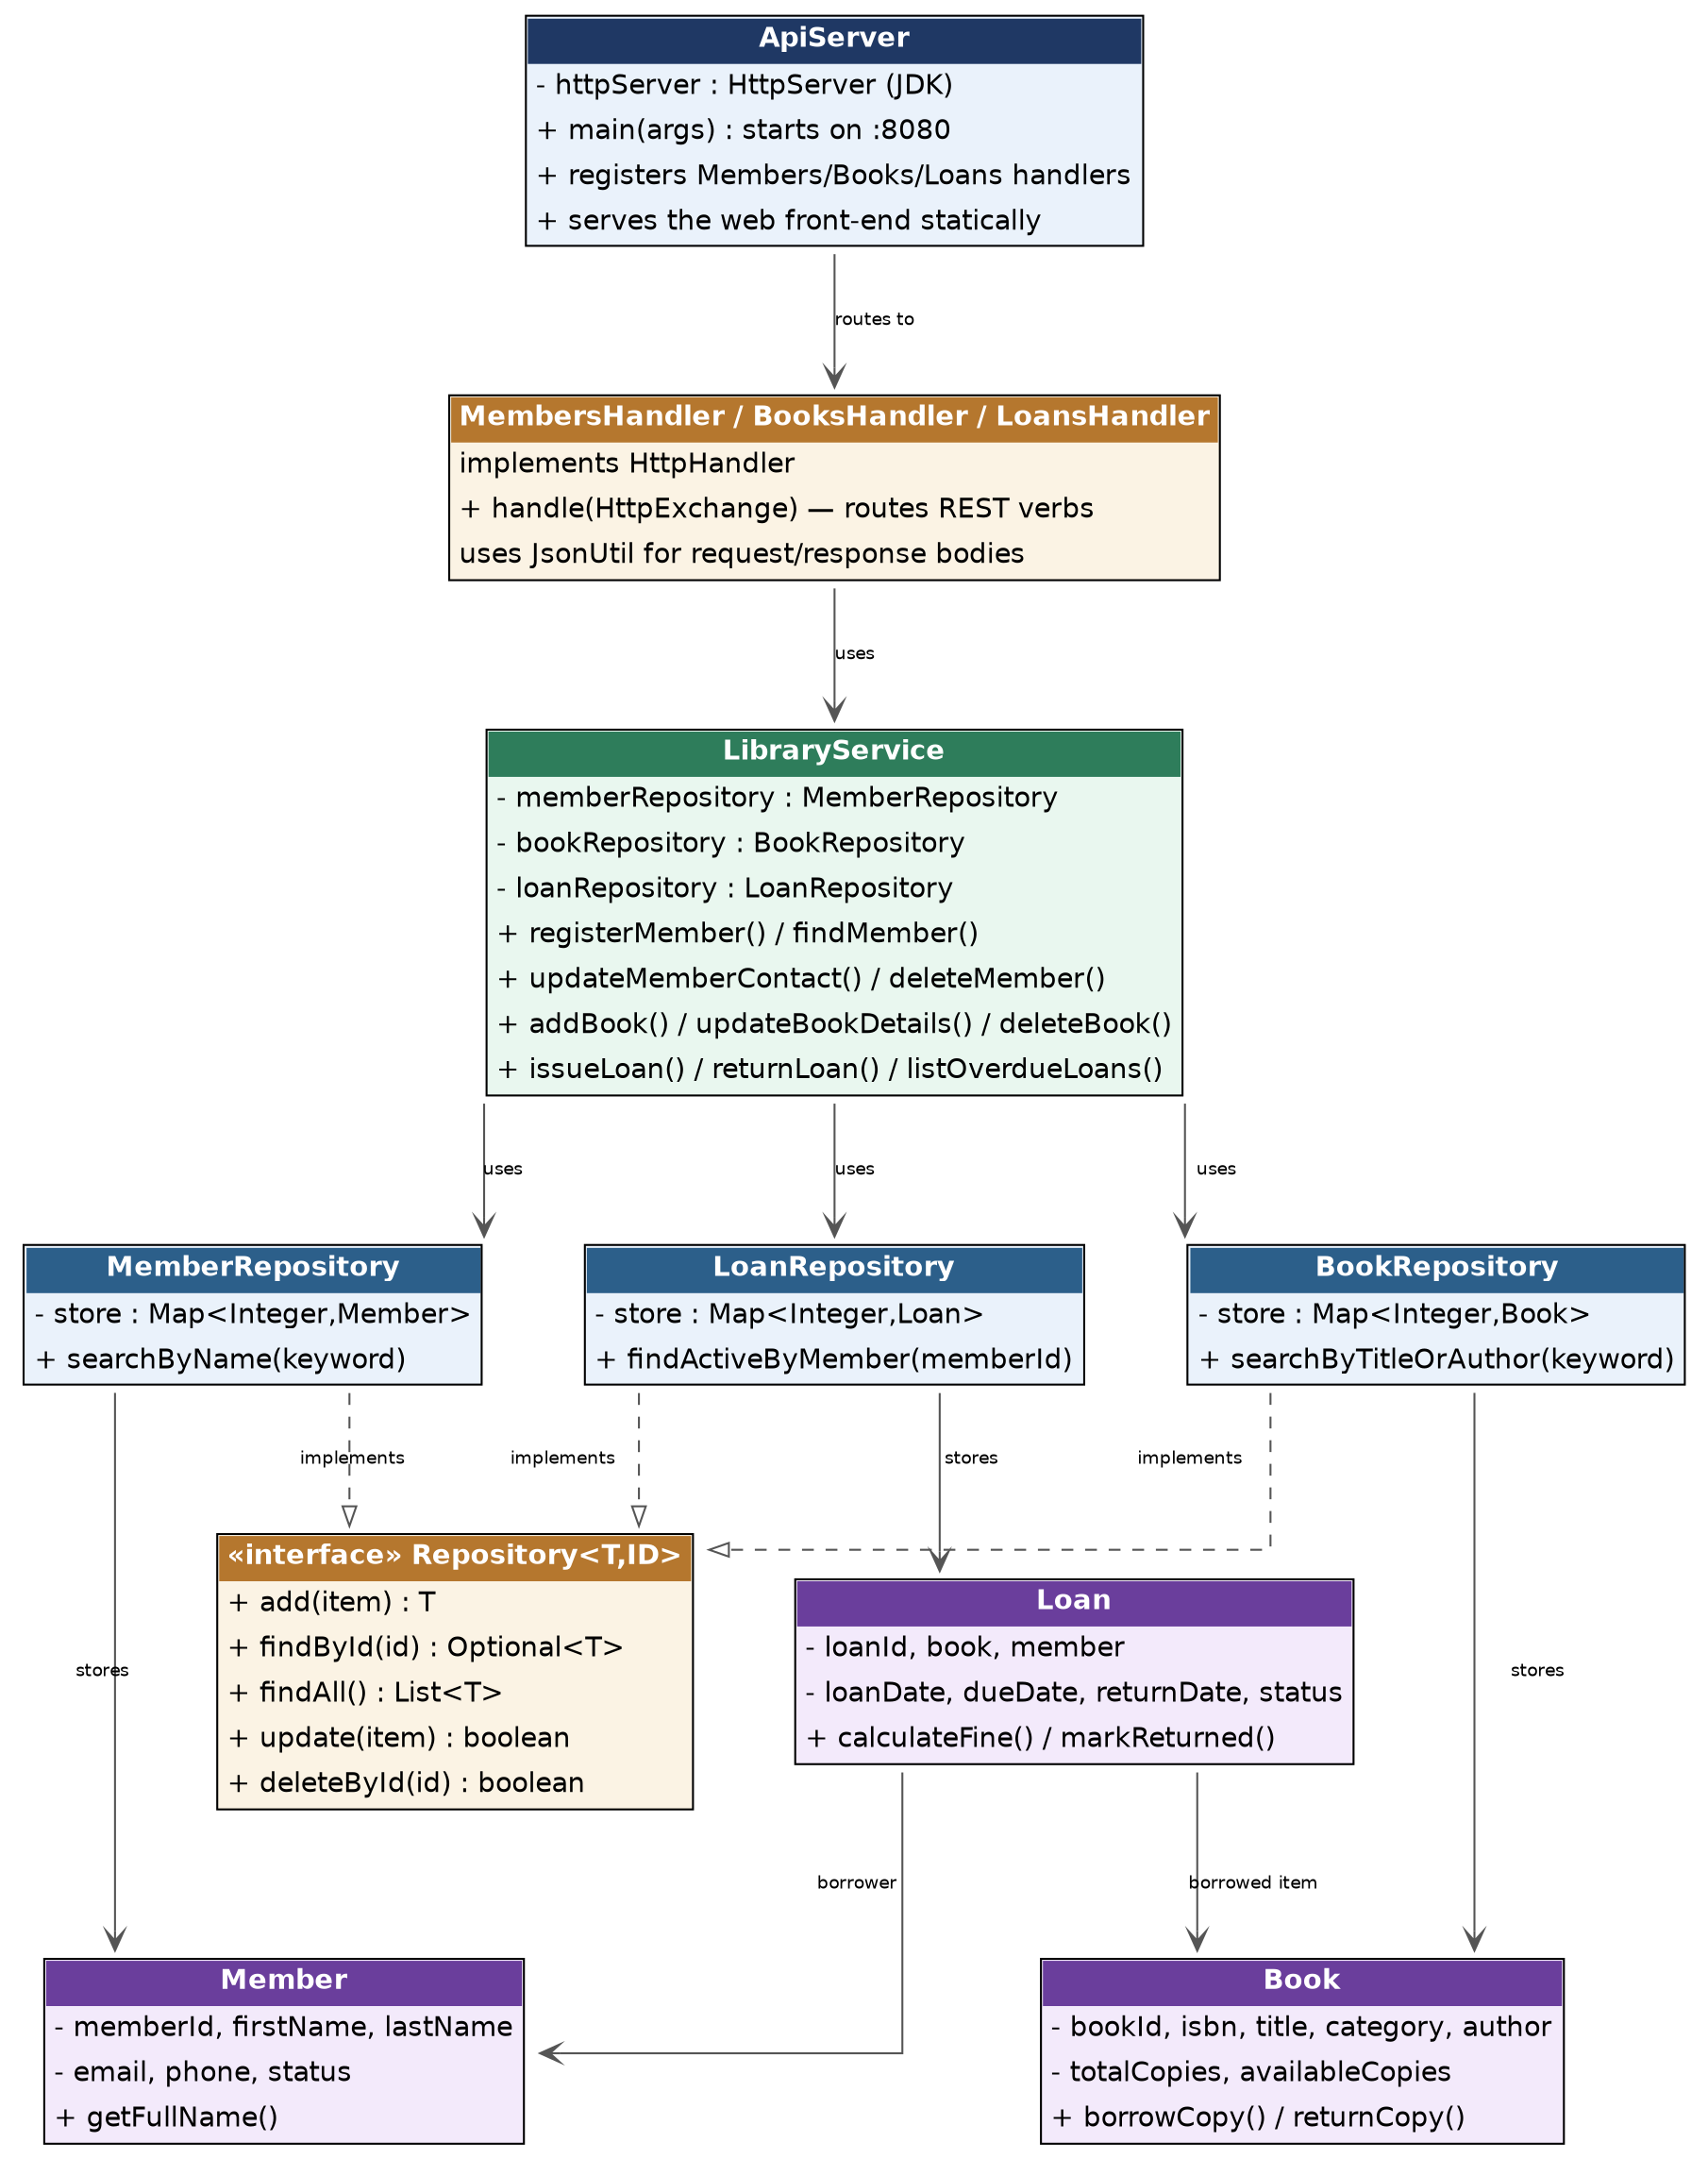
Figure 1: Class diagram showing the layered design and the Repository<T,ID> abstraction.

3.3 Object-Oriented Concepts Applied
- Encapsulation: every model class keeps its fields private and exposes controlled getters/setters (e.g. Book.borrowCopy() decrements availableCopies internally rather than letting external code edit the count directly).
- Abstraction / Interfaces: Repository<T,ID> defines a generic CRUD contract; MemberRepository, BookRepository and LoanRepository each implement it, so LibraryService can be written once against the interface.
- Enumerations: MembershipStatus and LoanStatus replace free-text strings with a fixed, type-safe set of values, matching the ENUM columns used in the Database Systems schema.
- Exception handling: a custom RecordNotFoundException plus IllegalArgumentException/IllegalStateException are thrown for invalid input or rule violations, and are caught centrally in each HTTP handler and translated into the correct status code (404/400) so a bad request never crashes the server.
- Separation of concerns: business rules (e.g. "a suspended member cannot borrow") live only in LibraryService, not scattered across the UI or storage layers.

4. API Endpoints (CRUD Matrix)
Every endpoint returns JSON and standard HTTP status codes (200/201 success, 400 validation/business-rule error, 404 not found).
Resource | Add | Search / List | Edit | Delete
Member | POST /api/members | GET /api/members  GET /api/members?search=kw | PUT /api/members/{id} | DELETE /api/members/{id}  (blocked while an active loan exists)
Book | POST /api/books | GET /api/books  GET /api/books?search=kw | PUT /api/books/{id} | DELETE /api/books/{id}  (blocked while a copy is on loan)
Loan | POST /api/loans (issue) | GET /api/loans  GET /api/loans?overdue=true | — (loans are only returned, not edited) | POST /api/loans/{id}/return  (closes the loan, returns any fine)

5. Implementation Walkthrough
Two representative methods from LibraryService are shown below; the full source is included alongside this report.

5.1 Issuing a loan (validation + state change)
public Loan issueLoan(int memberId, int bookId) {
Member member = findMember(memberId);
if (member.getStatus() != MembershipStatus.ACTIVE) {
throw new IllegalStateException("Member " + memberId + " is " + member.getStatus()
+ " and cannot borrow books.");
}
Book book = findBook(bookId);
if (!book.hasAvailableCopy()) {
throw new IllegalStateException("No available copies of \"" + book.getTitle() + "\".");
}
book.borrowCopy();
Loan loan = new Loan(0, book, member, LocalDate.now());
return loanRepository.add(loan);
}
This single method enforces two business rules (active membership, copy availability) before any state changes, so the system can never end up with more loans than physical copies.

5.2 Routing an HTTP request to the service layer
The API layer is a thin translation step: it parses the URL/body, calls LibraryService, and converts the result (or exception) into an HTTP response.
case "POST" -> {
Map<String, String> body = JsonUtil.parseFlatObject(ApiServer.readBody(exchange));
int memberId = Integer.parseInt(body.get("memberId"));
int bookId = Integer.parseInt(body.get("bookId"));
Loan loan = service.issueLoan(memberId, bookId); // <-- same service method as before
ApiServer.sendJson(exchange, 201, JsonUtil.toJson(loan));
}
// ...
} catch (IllegalStateException e) {
ApiServer.sendJson(exchange, 400, JsonUtil.error(e.getMessage()));
}
A business-rule violation (e.g. no available copies) still throws the same IllegalStateException from LibraryService; the handler's catch block is what turns that into an HTTP 400 with a JSON error body instead of a console message.

5.3 Overdue fine calculation
public static final double FINE_PER_DAY = 30.0;

public long daysOverdue(LocalDate today) {
if (!isOverdue(today)) return 0;
return ChronoUnit.DAYS.between(dueDate, today);
}

public double calculateFine(LocalDate today) {
return daysOverdue(today) * FINE_PER_DAY;
}
Fines only accrue once the due date has passed, and the rate (Rs. 30/day) is a single named constant so it can be changed in one place — this exact method is what the Software Testing unit's automated tests target.

6. How to Compile and Run
The project has no external dependencies beyond the JDK (21) — no Spring Boot, no Maven, no internet access required — so it builds with the standard command-line tools and runs as a plain HTTP server:
# from the project root
find src -name "*.java" > sources.txt
javac -d bin @sources.txt

# start the API (also serves the Web Programming unit's front-end from ./public)
java -cp bin com.library.api.ApiServer public

# the server prints:
# Library Automation System API running on http://localhost:8080
# Serving front-end static files from: <path>/public
With the server running, the site can be opened directly at http://localhost:8080/ in a browser, or the API can be exercised independently with curl/Postman as shown below.

7. Demonstration — Captured API Requests and Responses
The following is the actual, unedited output of a curl session against the running server, exercising create (POST), read (GET), the issue-loan business rule, and the two main error paths (400 business-rule violation, 404 not found):
$ curl http://localhost:8080/api/books
[
{
"bookId": 1,
"isbn": "978-0132350884",
"title": "Clean Code",
"category": "Computer Science",
"author": "Robert Martin",
"totalCopies": 2,
"availableCopies": 2
},
{
"bookId": 2,
"isbn": "978-0451524935",
"title": "1984",
"category": "Fiction",
"author": "George Orwell",
"totalCopies": 1,
"availableCopies": 0
},
{
"bookId": 3,
"isbn": "978-0062316097",
"title": "Sapiens",
"category": "Science",
"author": "Yuval Noah Harari",
"totalCopies": 1,
"availableCopies": 0
},
{
"bookId": 4,
"isbn": "978-0596007126",
"title": "Head First Java",
"category": "Computer Science",
"author": "Kathy Sierra",
"totalCopies": 2,
"availableCopies": 2
}
]

$ curl -X POST http://localhost:8080/api/members -d '{...}'
{
"memberId": 4,
"firstName": "Tharindu",
"lastName": "Bandara",
"fullName": "Tharindu Bandara",
"email": "tharindu@mail.com",
"phone": "0779990000",
"membershipDate": "2026-08-30",
"status": "ACTIVE"
}

$ curl -X POST http://localhost:8080/api/loans -d '{"memberId":1,"bookId":1}'
{
"loanId": 3,
"memberId": 1,
"memberName": "Nadeesha Perera",
"bookId": 1,
"bookTitle": "Clean Code",
"loanDate": "2026-08-30",
"dueDate": "2026-09-13",
"returnDate": null,
"status": "ACTIVE"
}

$ curl -X POST http://localhost:8080/api/loans -d '{"memberId":4,"bookId":2}' # expect rejection, book 2 has 0 available
{"error":"No available copies of \"1984\"."}
HTTP 400

$ curl -X GET http://localhost:8080/api/members/999 # expect 404
{"error":"Member 999 not found."}
HTTP 404

8. Conclusion
The Library Automation System backend meets the Software Programming unit requirements: it is an individually developed Java solution to a specific, real problem, it implements complete Add/Edit/Search/Delete functionality for its core entities, and it is built on a layered, testable design. Framing it as a REST API rather than a console menu also directly supports the Web Programming unit, which consumes these same endpoints from a browser front-end (see the Web Programming report). The Software Testing unit report (submitted alongside this one) verifies the underlying LibraryService business logic with 16 automated test cases, which remain valid unchanged because the API layer only translates requests — it introduces no new business logic of its own.

